**Software Evolution and Maintenance**

**FCAI-CU-SWE 2022**

For the Java project **University Timetabling (**<https://sourceforge.net/projects/unitime/>**)**  
you are now implementing the  maintenance activity you proposed in phase 1 and are using the settings defined in phase 1. We will only focus on the Java backend.   
  
  
Your tasks in this phase are:   
1.        
Provide UML (based on  
reverse engineering) of the java backend system.  
  
  
  
2.        
Register the change you  
proposed in phase 1, Implement the change and motivate it.  
  
  
3.        
Run impact analysis again  
and generate the new analysis report after the change is implemented.  
  
  
4.        
All of your work should be  
pushed to GitHub as pull requests and reviewed by team members.  
  
  
5.        
Show how the UML model obtained  
in 1  has changed after you implemented  the change.  
  
**Deliverables**  
1- Static Analysis Report for  code before changes.  
2- Class Diagram for the parts of interest to you.  
3- Static Analysis Report For changed code

4- Class Diagram after implementing the change.  
5- Opened Tickets for Issues  
Notes:  
• All of the required deliverables will be pushed to your Github repository, all team members must use  
Github to push their tasks.  
• You should submit a text or pdf file with your names and github repo (don’t push anything after deadline),  
the file should have the following format: file name: Group_1stStudentId_2ndStudentId_3rdStudentId_4thStudentId

**Team Member:**

|  |  |  |
| --- | --- | --- |
| ID | Name | GitHub Username |
| 20196037 | Amr Halaby | AmrHalaby |
| 20196026 | Sohaila Gamal | Sohailla |
| 20206023 | Dalia Gamal | DaliaGamal11 |
| 20196003 | Ahmed Gamal | Ahmedgemy2002@gmail.com |

* **GitHub Repository:** https://github.com/Sohailla/uni-time
* **Static Analysis Report for  code before changes.**

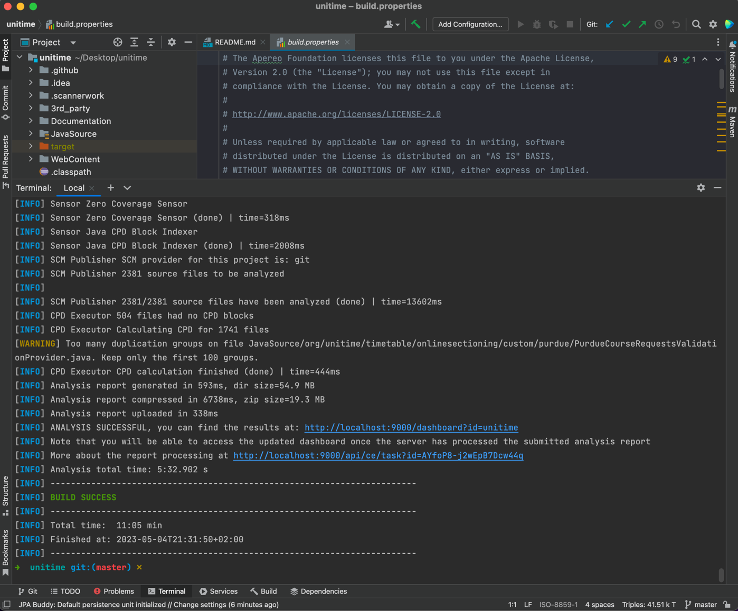

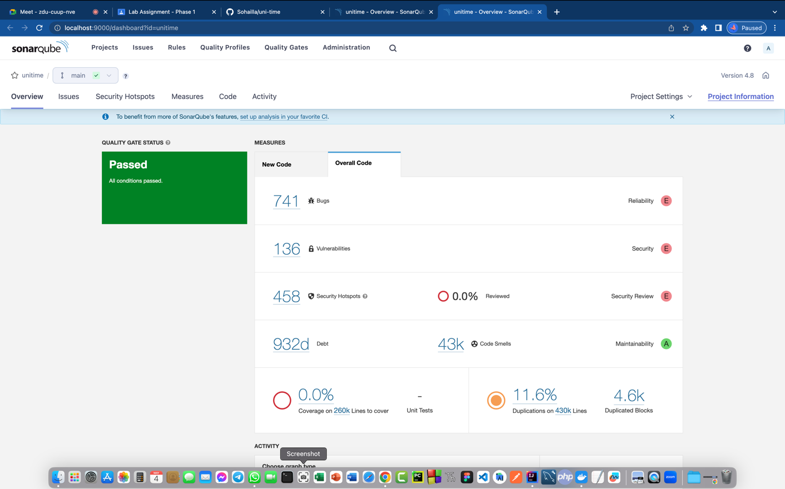

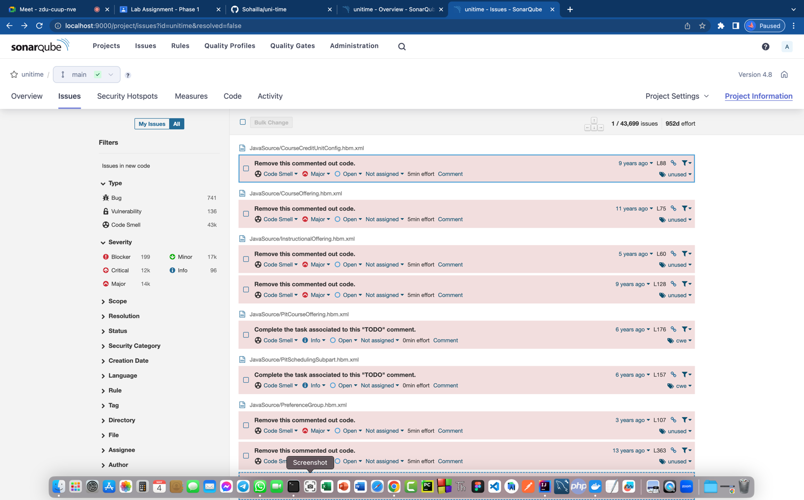

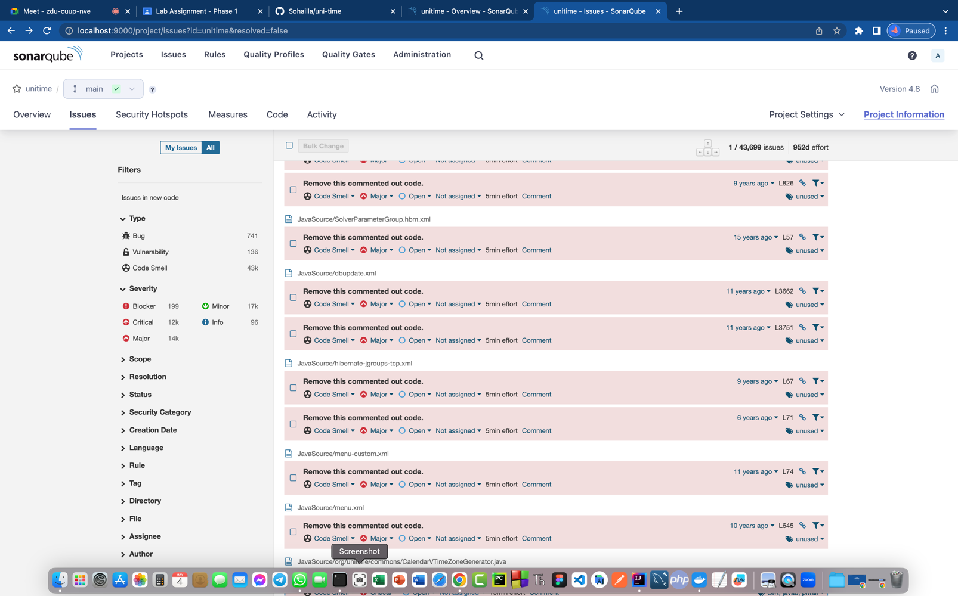

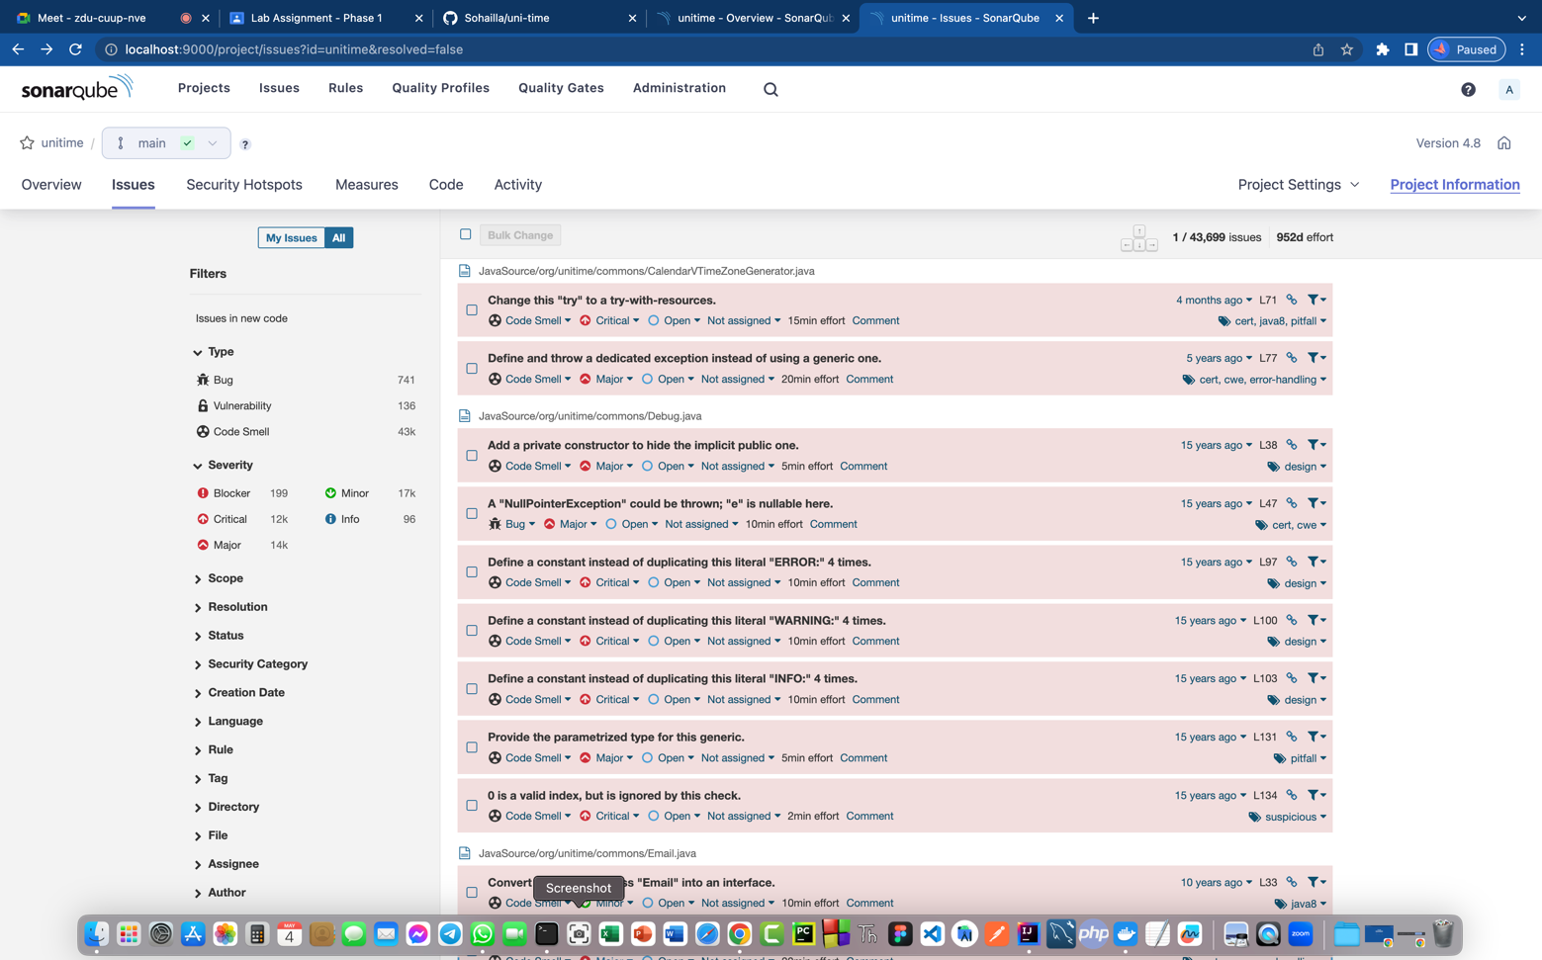

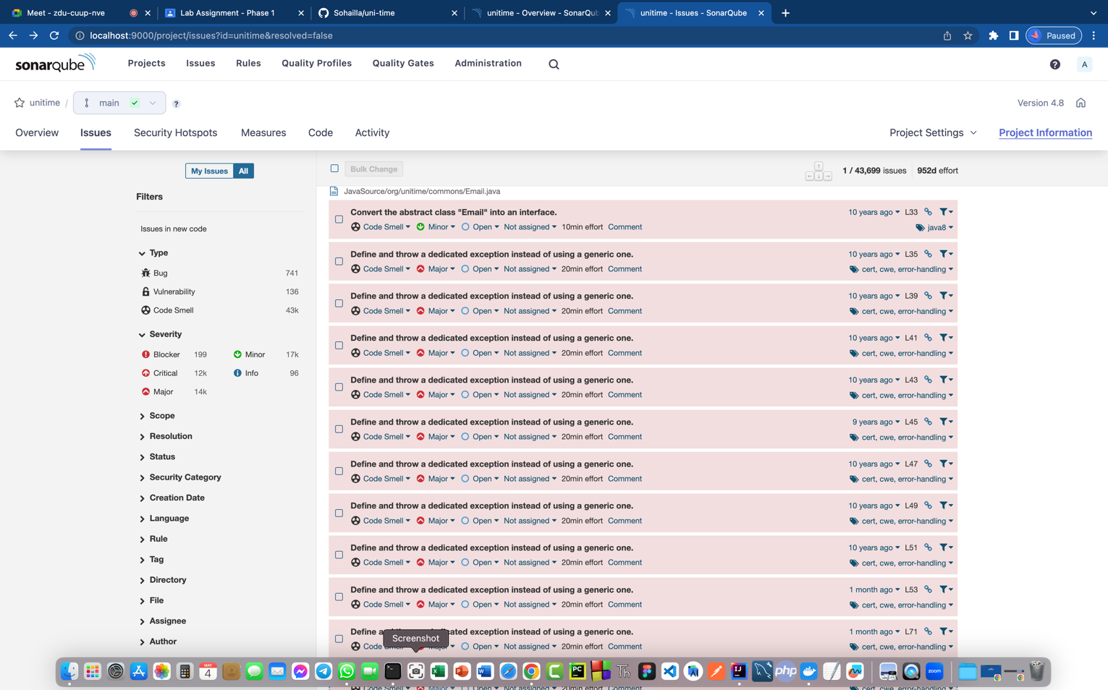

* **Class Diagram for the parts of interest to you**

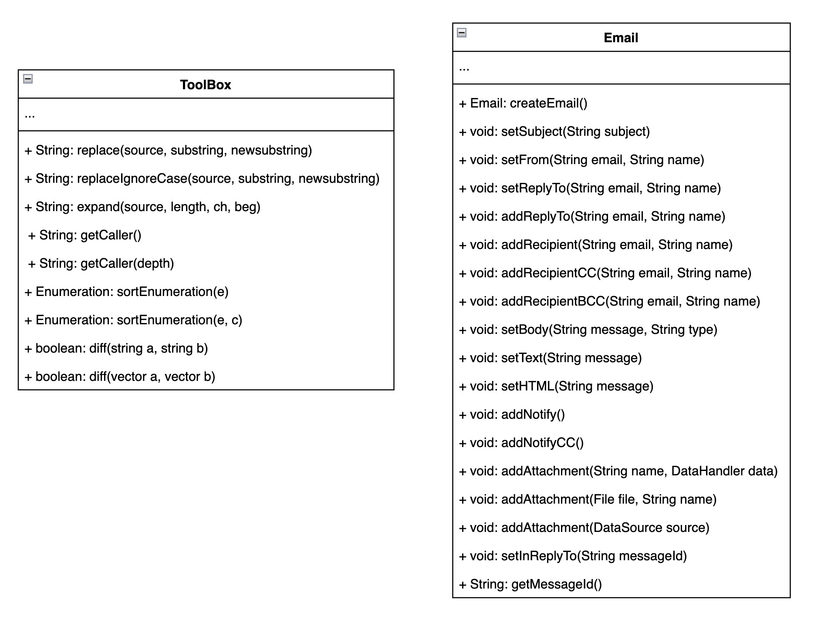

* **The Static Analysis Report For changed code**

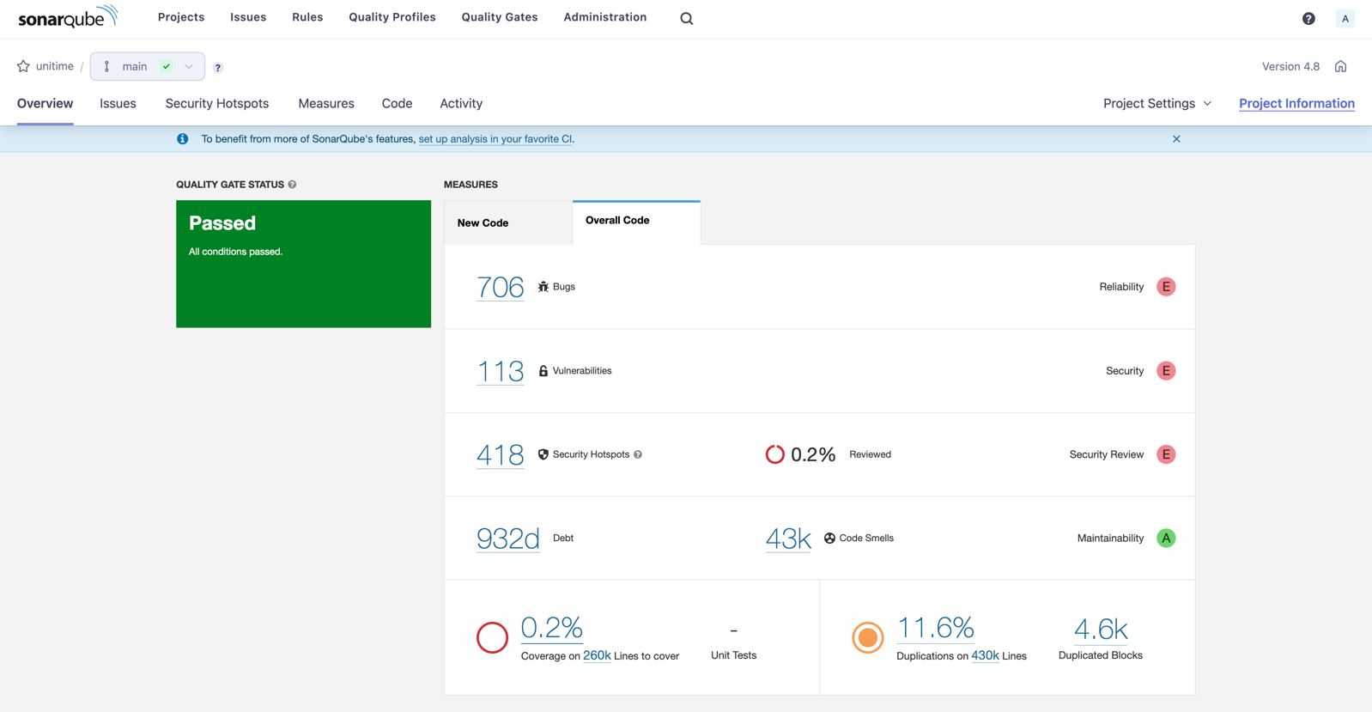

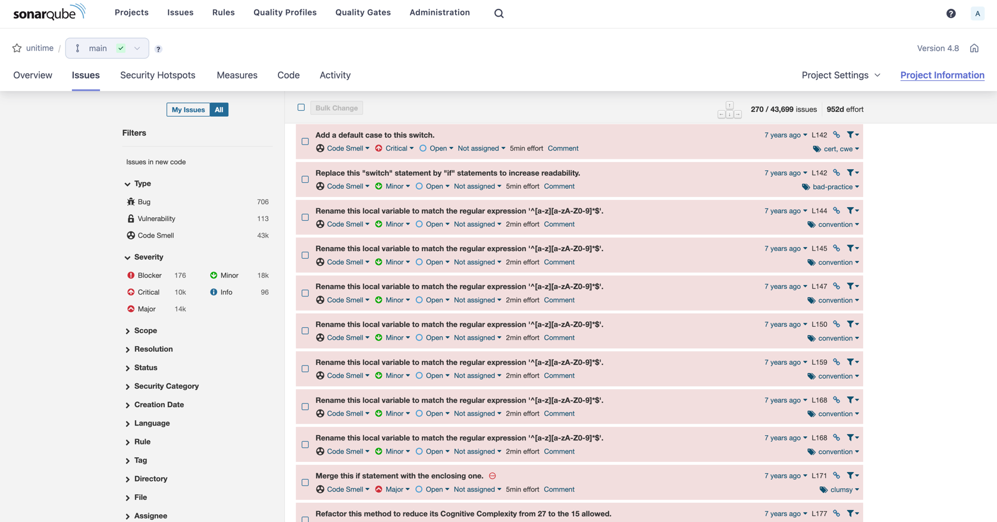

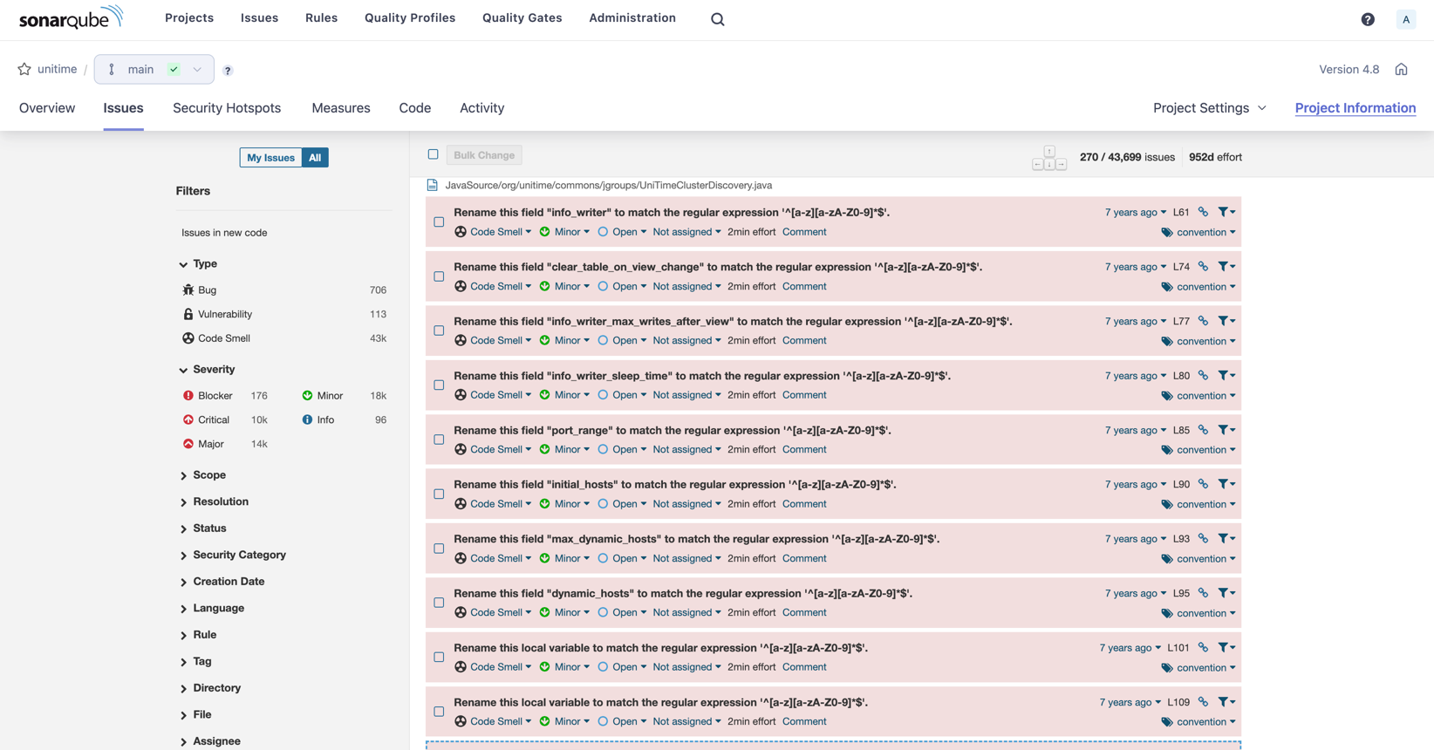

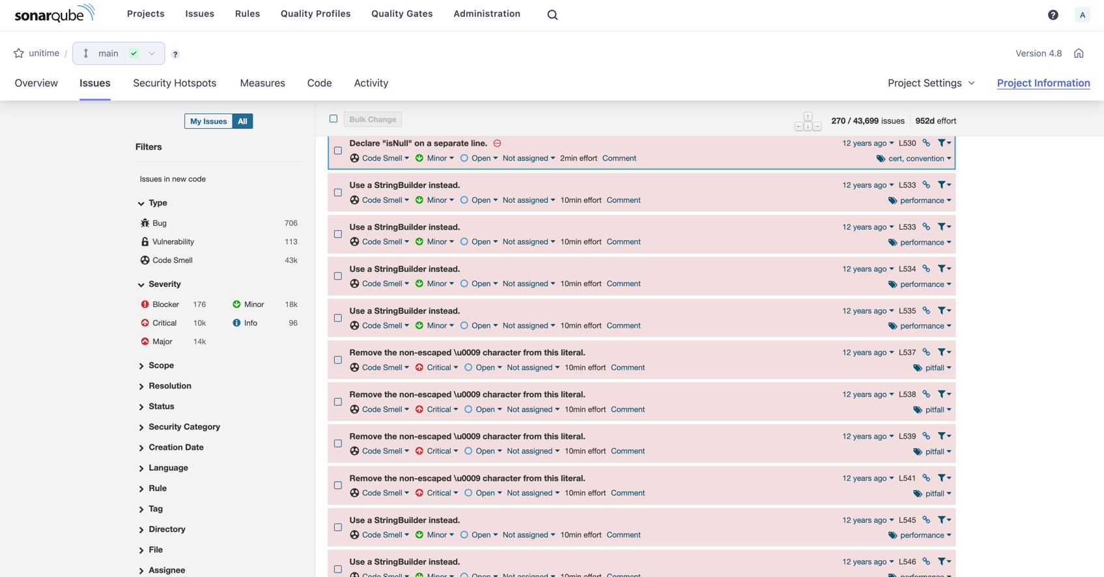

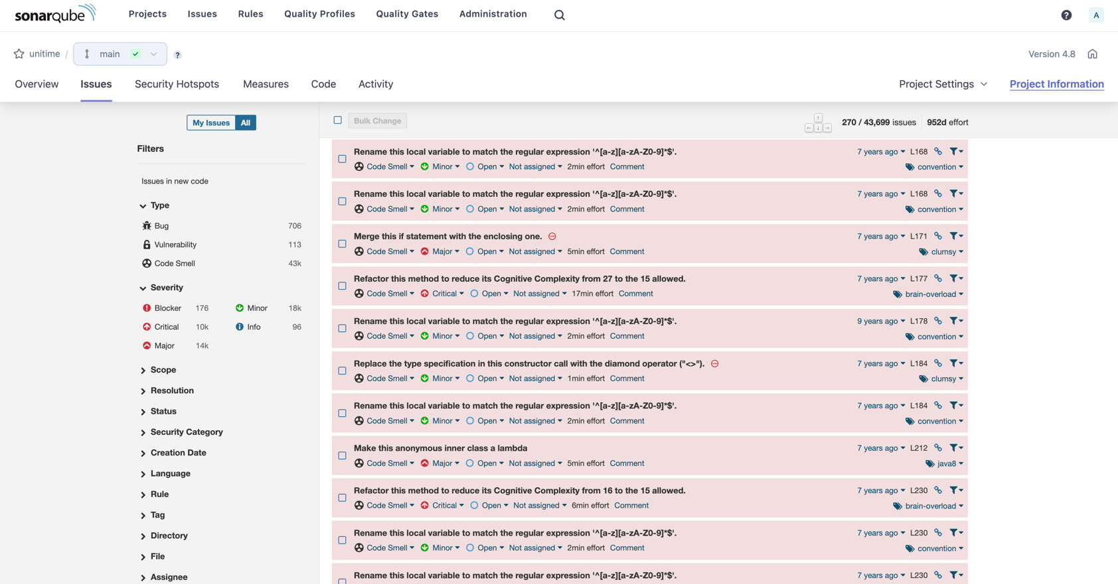

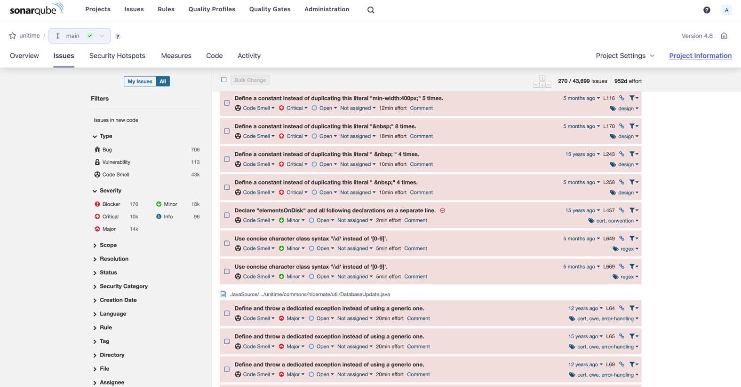

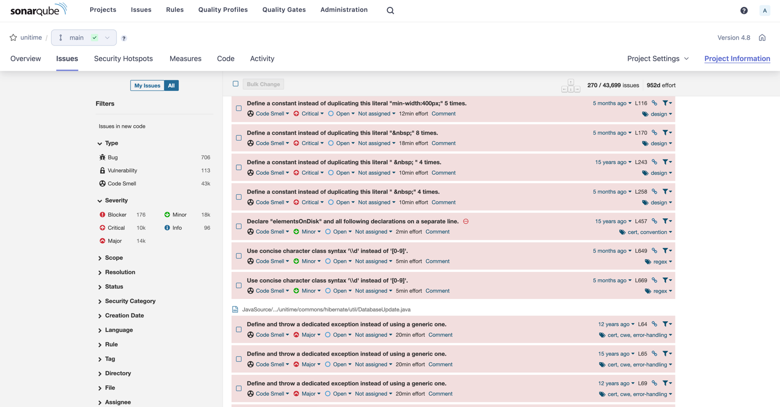

* **A Class Diagram after implementing the change**

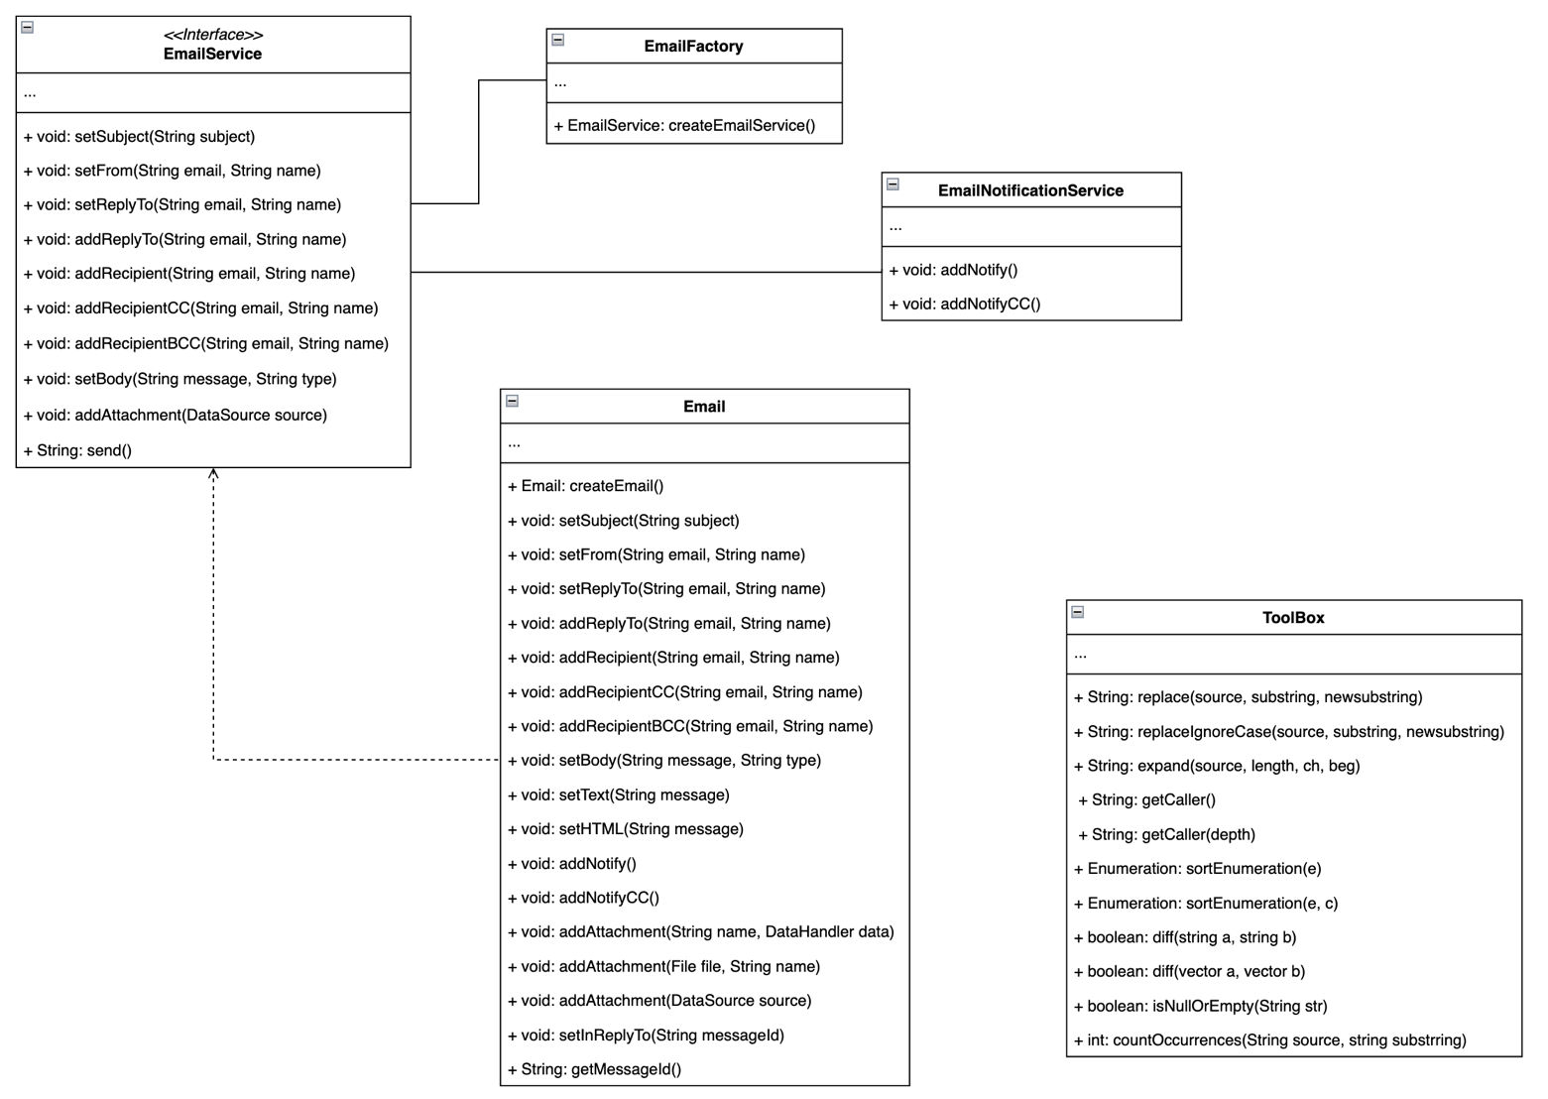

* **Ticketing System [Trello]:** <https://trello.com/b/nGqGdbd8/uni-time>

